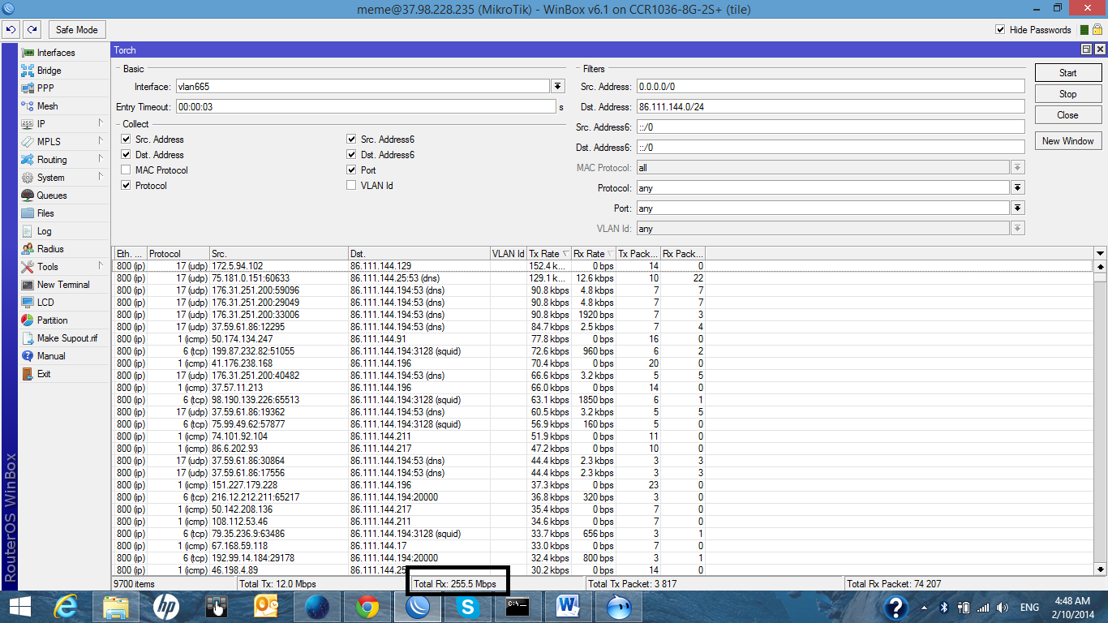

MAC-PROTOCOL SRC-ADDRESS
ip 79.134.138.4
ip 46.55.27.78
ip 69.156.219.133
ip 94.11.182.178
ip 37.201.216.113
ip 50.148.210.225
ip 46.250.168.37
ip 82.77.145.194
ip 195.211.49.72
ip 94.249.47.203
ip 27.96.209.3
ip 72.207.13.165
ip 69.171.233.97
ip 202.160.18.11
ip 62.201.248.226
ip 179.177.221.220
ip 82.29.103.47
ip 172.5.204.149
ip 68.60.162.176
ip 190.172.78.163
ip 196.217.162.108
ip 180.148.55.241
ip 5.149.99.91
ip 37.107.40.121
ip 109.251.126.50
ip 118.170.209.78
ip 178.85.111.6
ip 159.255.164.161
ip 54.217.200.102
ip 67.180.195.94
ip 74.125.218.55
ip 69.126.131.6
ip 94.211.91.128
ip 186.212.221.44
ip 65.95.105.140
ip 74.125.218.210
ip 50.181.185.151
ip 72.20.55.115
ip 176.57.188.28
ip 38.88.12.214
ip 5.103.221.215
ip 74.125.216.210
ip 41.143.46.206
ip 122.106.165.75
ip 112.203.200.97
ip 49.144.72.187
ip 72.251.244.197
ip 202.122.52.37
ip 80.56.48.187
ip 203.205.142.143
ip 198.46.136.254
ip 49.213.35.138
ip 61.9.212.168
ip 74.125.218.116
ip 89.93.122.151
ip 125.209.252.77
ip 72.251.244.197
ip 216.10.213.131
ip 85.166.82.52
ip 2.121.86.237
ip 64.85.253.127
ip 208.94.232.191
ip 93.120.228.10
ip 188.49.237.219
ip 49.183.111.227
ip 181.47.34.130
ip 74.125.216.240
ip 41.225.254.112
ip 68.235.8.53
ip 79.134.139.200
ip 213.49.122.48
ip 75.155.83.91
ip 62.201.248.78
ip 67.164.200.55
ip 41.129.178.102
ip 203.205.161.180
ip 125.209.252.77
ip 216.127.64.68
ip 176.31.185.112
ip 198.40.55.186
ip 68.207.147.184
ip 24.133.103.77
ip 67.82.217.116
ip 185.23.155.35
ip 70.66.6.175
ip 5.10.229.151
ip 50.67.86.229
ip 54.220.166.226
ip 37.229.228.43
ip 75.140.19.164
ip 31.222.174.111
ip 76.92.214.37
ip 66.65.6.246
ip 182.178.111.237
ip 69.171.233.98
ip 190.99.223.207
ip 37.105.82.131
ip 101.128.162.244
ip 195.211.15.142
ip 88.244.9.205
ip 203.205.161.49
ip 176.28.74.101
ip 54.217.200.11
ip 24.182.20.197
ip 37.107.126.3
ip 90.229.248.195
ip 188.4.22.25
ip 123.237.217.109
ip 42.60.165.120
ip 79.181.109.107
ip 203.205.161.49
ip 124.147.93.126
ip 5.108.25.195
ip 76.120.143.58
ip 84.109.80.155
ip 74.125.216.112
ip 142.165.171.39
ip 179.180.132.106
ip 185.12.240.136
ip 83.223.160.197
ip 74.125.216.145
ip 203.205.161.49
ip 75.140.148.134
ip 74.125.216.176
ip 31.13.100.98
ip 149.200.184.172
ip 150.250.242.230
ip 203.205.161.180
ip 39.32.43.227
ip 203.205.161.180
ip 80.70.233.31
ip 24.178.146.243
ip 24.128.168.165
ip 72.251.244.195
ip 96.242.56.27
ip 24.109.200.77
ip 98.242.101.10
ip 78.53.84.62
ip 192.0.227.135
ip 185.4.149.15
ip 192.135.141.2
ip 85.229.57.161
ip 119.10.216.2
ip 77.248.19.16
ip 69.171.248.82
ip 74.125.216.52
ip 68.40.131.221
ip 62.201.248.169
ip 109.127.86.113
ip 54.207.41.104
ip 203.205.161.180
ip 93.25.117.38
ip 24.31.150.213
ip 24.150.204.134
ip 176.221.179.188
ip 124.147.74.192
ip 87.119.176.162
ip 92.253.17.1
ip 77.72.168.168
ip 69.171.246.98
ip 186.28.151.168
ip 41.232.12.49
ip 37.32.191.67
ip 69.158.41.85
ip 151.70.19.156
ip 84.245.203.214
ip 85.17.196.147
ip 37.232.212.54
ip 78.88.122.19
ip 90.145.135.23
ip 5.164.207.3
ip 94.23.184.209
ip 24.86.164.246
ip 46.228.42.106
ip 74.125.216.20
ip 212.252.170.11
ip 99.254.80.148
ip 37.49.191.50
ip 72.10.169.210
ip 81.166.253.42
ip 146.66.159.10
ip 176.44.226.51
ip 54.217.200.91
ip 178.221.230.5
ip 5.1.111.237
ip 68.71.62.135
ip 201.253.222.217
ip 115.187.37.12
ip 203.205.161.49
ip 195.91.242.47
ip 54.217.200.100
ip 79.16.118.69
ip 5.153.6.213
ip 39.50.153.82
ip 74.125.218.20
ip 203.205.161.55
ip 5.149.105.70
ip 105.184.33.136
ip 185.25.181.206
ip 83.212.103.232
ip 94.211.149.73
ip 201.53.48.2
ip 109.153.127.214
ip 177.5.69.159
ip 74.125.218.83
ip 31.209.219.178
ip 82.40.151.4
ip 54.217.200.109
ip 178.90.200.105
ip 128.69.248.210
ip 93.187.32.34
ip 54.217.200.113
ip 78.184.31.240
ip 74.125.216.176
ip 74.125.216.177
ip 177.148.213.115
ip 117.253.185.245
ip 24.92.174.163
ip 129.97.124.177
ip 5.10.229.188
ip 74.125.216.178
ip 79.170.54.186
ip 74.125.218.51
ip 203.205.161.55
ip 71.236.233.202
ip 190.67.39.74
ip 72.251.244.201
ip 5.187.99.90
ip 2.123.30.174
ip 203.205.161.178
ip 203.205.161.47
ip 46.253.198.225
ip 202.170.69.66
ip 74.125.216.209
ip 5.103.50.89
ip 98.243.152.184
ip 91.106.32.7
ip 23.119.117.127
ip 69.171.233.98
ip 203.205.161.177
ip 37.1.45.181
ip 54.217.200.103
ip 69.166.172.110
ip 84.108.19.116
ip 5.149.105.124
ip 5.42.200.151
ip 54.228.191.4
ip 54.220.180.71
ip 72.252.136.173
ip 81.224.138.82
ip 85.180.85.55
ip 70.239.10.176
ip 65.128.68.253
ip 84.228.50.78
ip 74.125.216.181
ip 36.39.118.132

ip 111.241.46.230
ip 54.217.200.16
ip 79.196.186.185
ip 62.201.248.32
ip 69.171.233.98
ip 188.161.11.179
ip 54.217.200.92
ip 54.217.200.104
ip 77.253.62.42
ip 67.188.200.251
ip 121.102.108.105
ip 72.230.139.12
ip 69.171.248.81
ip 89.152.179.23
ip 109.255.54.56
ip 109.123.89.151
ip 74.125.218.49
ip 176.31.102.18
ip 24.9.224.110
ip 5.109.44.4
ip 54.217.200.16
ip 94.23.184.211
ip 100.0.63.116
ip 203.205.161.55
ip 82.240.82.73
ip 54.217.200.101
ip 54.217.200.108
ip 46.32.105.8
ip 54.196.198.132
ip 46.43.79.92
ip 31.59.206.113
ip 54.217.200.111
ip 54.217.200.75
ip 31.186.242.129
ip 74.125.216.243
ip 184.173.78.216
ip 54.217.200.95
ip 183.247.236.136
ip 179.216.7.55
ip 87.6.82.196
ip 37.58.79.2
ip 203.205.161.180
ip 24.49.213.99
ip 74.125.218.147
ip 109.254.34.117
ip 74.125.216.84
ip 24.182.166.56
ip 198.211.14.85
ip 92.232.212.240
ip 24.36.0.217
ip 85.243.48.160
ip 39.112.197.151
ip 105.236.140.107
ip 77.106.88.180
ip 79.119.113.135
ip 79.165.209.163
ip 37.75.4.224
ip 121.202.251.136
ip 78.148.123.215
ip 67.252.185.67
ip 213.22.254.226
ip 2.51.26.61
ip 88.154.11.243
ip 212.41.63.241
ip 121.223.43.72
ip 41.140.233.65
ip 24.114.101.91
ip 124.254.15.10
ip 54.228.191.53
ip 202.134.6.82
ip 199.255.210.36
ip 77.185.192.73
ip 31.214.41.123
ip 74.125.216.117
ip 95.236.182.62
ip 74.125.218.209
ip 199.255.15.253

ip 54.217.200.101
ip 82.232.198.122
ip 24.127.168.134
ip 211.30.214.73
ip 79.107.10.192
ip 98.242.226.58
ip 68.62.138.86
ip 200.91.134.50
ip 69.171.246.97
ip 54.217.200.114
ip 49.144.216.20
ip 177.41.79.88
ip 86.111.146.18
ip 78.143.25.2
ip 92.98.60.234
ip 185.12.240.107
ip 31.192.120.116
ip 217.164.25.94
ip 190.203.87.238
ip 83.81.86.124
ip 69.171.233.97
ip 187.64.90.153
ip 74.125.216.177
ip 70.30.192.134
ip 54.228.191.199
ip 173.45.110.135
ip 65.183.153.46
ip 197.155.64.150
ip 203.205.161.47
ip 107.221.126.29
ip 88.173.128.120
ip 198.211.23.26
ip 5.108.107.52
ip 85.197.168.253
ip 23.233.214.179
ip 41.133.234.77
ip 76.112.73.131
ip 5.54.103.4
ip 2.8.174.67
ip 88.150.176.131
ip 74.125.216.117
ip 99.225.34.177
ip 75.64.2.170
ip 190.213.133.129
ip 76.226.139.243
ip 107.194.77.134
ip 94.236.85.37
ip 88.198.179.155
ip 91.121.50.72
ip 82.47.158.110
ip 54.228.191.195
ip 68.168.223.144
ip 86.110.32.70
ip 196.205.183.135
ip 41.234.185.240
ip 62.248.44.151

